Recruitment Business Case

Hiring manager | Zara Edward
Discipline + Cost centre(s) | Facades - 3611
Anticipated grade(s) | Director
Number of hires | 1
Reason for recruitment | Sustained growth + strategic appointment
Role in budget? | Yes (backfill)
Required start date of new hire | 06-2026
Job title | Director – North Regional Lead

People - how does this new hire fit within your team?
There has been a resignation of a Director in the Facades team (Rob Stephens). This has opened a growth opportunity for the team to fill up into the space left behind, which would be welcomed by the ambitious Associates and Associate Directors. Therefore, rather than a like-for-like London replacement, it is proposed to reallocate the vacancy to another regional office (ideally Manchester) to support a more balanced regional leadership model. The model is illustrated below. The position would be advertised as a “Regional Façade Lead for the North” and would attract applicants suiting either Associate Director or Director role, critically because there is a smaller pool of potential recruits in Façade Engineering outside of London.
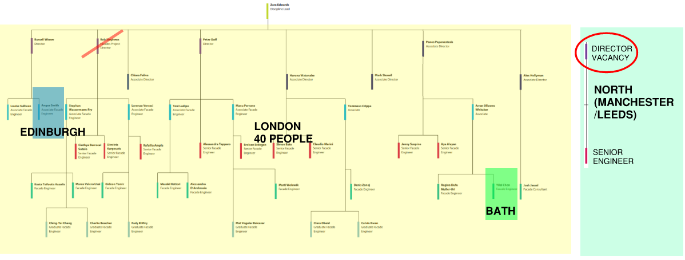
The appointment of a lead at Director or Associate Director level will address the loss of technical experience and will also generate the UK work-winning contribution that would have otherwise come from Rob. Ideally the position would be filled as close as possible to the termination date of Rob Stephens, which is between mid-May when Gardening leave is taken.
The appointment in Manchester or Leeds will enable the business to accelerate growth across the North of England and potentially contribute to growth in Scotland. It will strengthen leadership presence and client engagement in Manchester, Leeds and Edinburgh, while creating headroom for the existing London team to step up into the space left by the departing Director. This approach supports succession planning in London, reduces over-reliance on a single regional hub, and positions the business to actively drive growth in another key region.

The timing for this recruitment fits well with the arrival of our first Façade team member in the Manchester office (starting on 20th May). They are a Senior Engineer and will benefit from having a regional lead. The potential for work-winning will be enhanced by having more than one person located in the region – giving resilience and a good foundation to grow the team further.
Their role will be as follows:
- Act as a regional leadership presence outside London, with a primary base in Manchester, supporting and growing the Engineering offering across Manchester, Leeds and Edinburgh.
- Drive business development and client relationships in the North and Scotland, working closely with Regional, Sector and Discipline leadership to convert opportunities into secured work.
- Provide technical leadership and project delivery oversight, drawing on strong experience in façade consultancy, including the delivery of complex projects.
- Build, lead and develop a regional team, including recruitment, mentoring, capability development and succession planning aligned with business growth.
- Actively network within the industry, strengthening the firm’s profile with architects, developers, contractors and other key stakeholders in the region.
- Collaborate with London and other UK offices to ensure consistent quality, technical excellence and knowledge sharing across the practice.

Pipeline – is this new hire needed to deliver current and planned workload?
The new hire will be essential from a headcount perspective. Their role will be focussed on generating business opportunities and growing our pipeline.
The current pipeline shows that, with the 90% likely project wins, we will be in deficit of FTE’s up to June. There has been a recent increase in pipeline opportunities which is not reflected here (Roshan Stadium, 1&2 Minster Court, Bruntwood Plot 3 (in Manchester), South Riyadh Stadium and King Saudi University Stadium). There is a keen refocus from the team on Pipeline following a Dec-Feb distraction on project deadlines.

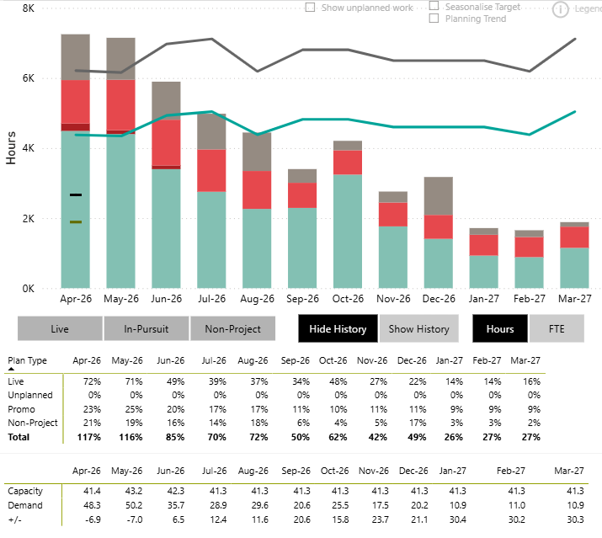

Utilisation for the last closed month is higher than the target, equating to 250+hours or 1.75 FTE’s.

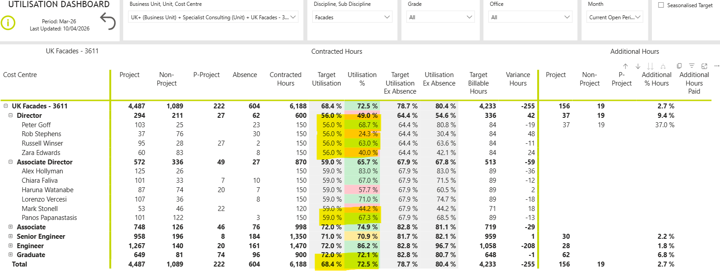
Financials – how would this new hire affect profit, work winning and delivery of projects?
The predominant initial benefit from the new hire would be in work winning and delivery of projects.
Having a new regional lead located to serve the North will generate a new interest in BH Façade service offerings to Clients who expect a local presence. We have also got encouragement from the local Partners who have identified a need for local presence to serve the Northern markets. The other key engineering disciplines have Northern presence and we can start to join forces to offer our façade services to their Clients to organically grow the business. The Director will also have existing contacts in the North to supplement existing BH Clients and to generate more business.
The Director would provide Technical leadership in a PD role or DRE role for our projects. With the loss of Rob from the team we will be stretched in providing this. The utilisation of Peter is consistently high and so he cannot take any of the workload. Russell is serving Expert Witness projects and potentially could fill in some DRE work of Russell’s, but is already utilised above his target. Zara could accommodate more, but not all of Rob’s capacity. Panos is now a Director and is over-utilised.
The appointment would not serve to improve Profit immediately, instead it would resolve the quality risk from reduced seniority in the team and serve to be a longer-term strategic business growth strategy to generate more work from the North.

